EC-231 Operating Systems
BS(CE)-2021
LAB REPORT # 3

Submitted By:
Reg. No. | Name
21-CE-009 | Huzaifa Shahbaz

Department of Computer Engineering
BS Computer Engineering Program
HITEC University Taxila
 | Presentation  (Format (0.5) + Title (0.5) +  Conclusion(1) + Procedure(2) + Objective(1)) | Calculation/Coding | Observation/ Program Results | Total
Total | 5 | 5 | 5 | 15
Obtained

___________________________
Lab Instructor.
Engr. Fasih Ahmad
Experiment #3
Basic Shell scripting using gedit/vi
Objective: 1.Vi Introduction 2.Setting access permission of files 3.Executing shell script 4.User and System Variables 5.Shell Arithmetic 6.Exit status

Software Used: 1. Ubuntu 2. gedit/vi(Text Editor)

Procedure: Introduction to Vi: Under Linux, there is a free version of Vi called Vim (Vi Improved). Vi (pronounced vee-eye) is an editor that is fully in text mode, which means that all actions are carried out with the help of text commands. This editor, although it may appear of little practical use at first, is very powerful and can be very helpful in case the graphical interface malfunctions. Syntax: 1.vi name_of_the_file 2.Once the file is open, you can move around by using cursors. 3.Press I to switch to insert mode. 4.Press escape key to switch to command mode. How to write shell script: Following steps are required to write shell script: 1.Use any editor like vi or gedit to write shell script. 2.To close vi window press : and then given command (i.e. q ,!q or wq) 3.To save and close gedit window press ALT+F4 4.After writing shell script set execute permission for your script as follows. Variables in Shell: To process our data/information, data must be kept in computers RAM memory. RAM memory is divided into small locations, and each location had unique number called memory location/address, which is used to hold our data. Programmer can give a unique name to this memory location/address called memory variable or variable (Its a named storage location that may take different values, but only one at a time). In Linux (Shell), there are two types of variable: (1) System variables: Created and maintained by Linux itself. This type of variable defined in CAPITAL LETTERS. (2) User defined variables (UDV): Created and maintained by user. This type of variable defined in lower letters. You can see system variables by giving command like $ set, some of the important System variables are: HOME, USER

Tasks
Task 1: Stimulate following commands in Linux and note down the exit status: a. $ expr 1+3 CODE: 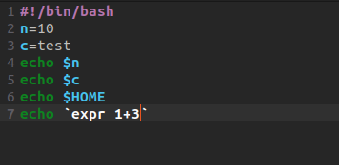 Output: 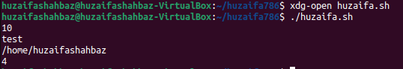 b. $ echo $? CODE: 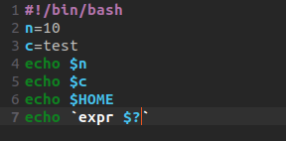 Output: 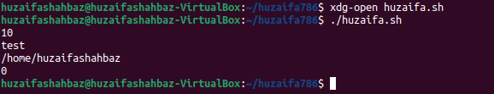 c. $ echo Welcome CODE: 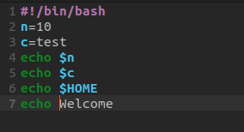 Output: 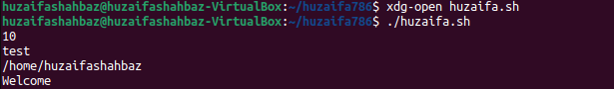 d. $ echo $? CODE: 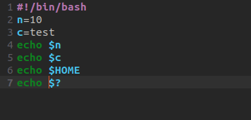 Output: 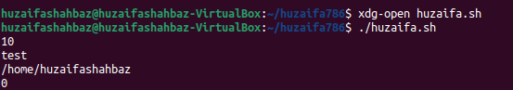 e. $ wildwestcanwork? CODE: 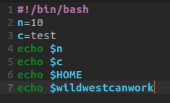 OUTPUT: 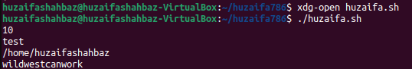 f. $ echo$? CODE: 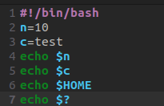 OUTPUT: 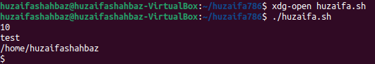
g. $date CODE: 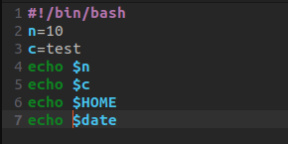 OUTPUT: 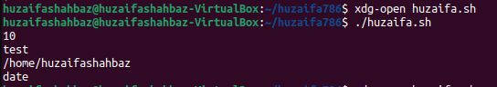
h.$ echo $ CODE: 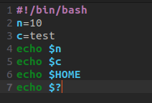 OUTPUT:  i.$ echo$? CODE:  OUTPUT:  j.$ echo$? CODE:  OUTPUT: 
Task 2: Simulate command/commands in Linux to define variable x with value 10 and print it on screen. Check exit status.
CODE: 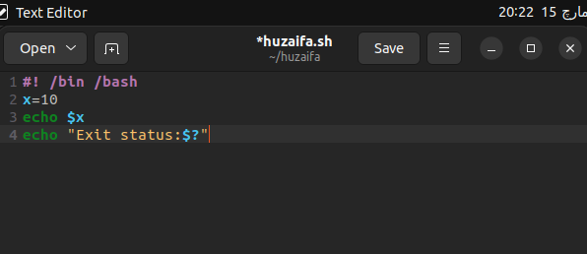 Output: 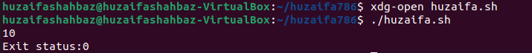
Task 3: Simulate command/commands in Linux to define variable xn with value Hello and print it on screen. Check exit status.
CODE: 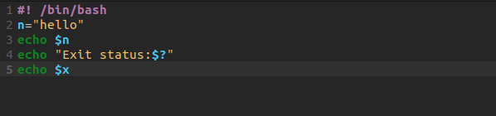 OUTPUT: 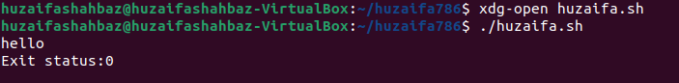
Task 4: Simulate command/commands in Linux to print sum of two numbers, let's say 6 and 3? CODE: 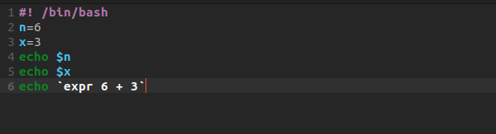 OUTPUT: 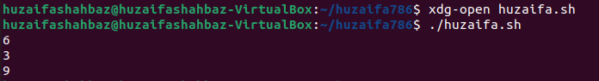
Task 5: Simulate command/commands in Linux to define two variable x=20, y=5 and then to print division of x and y (i.e. x/y). CODE: 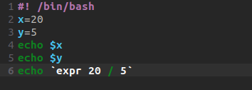 OUTPUT: 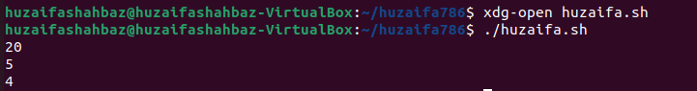
Task 6: Simulate command/commands in Linux to modify above and store division of x and y to variable called z. CODE: 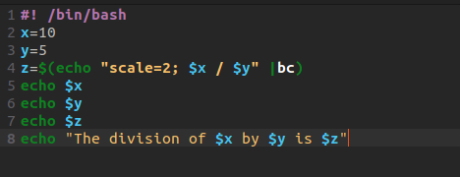 OUTPUT: 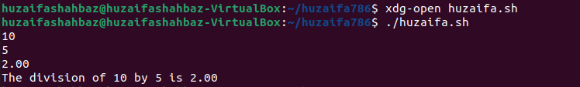
Task 7: Simulate command/commands in gedit to make a simple calculator in which addition, multiplication, subtraction and division on two user defined variables is calculated. CODE: 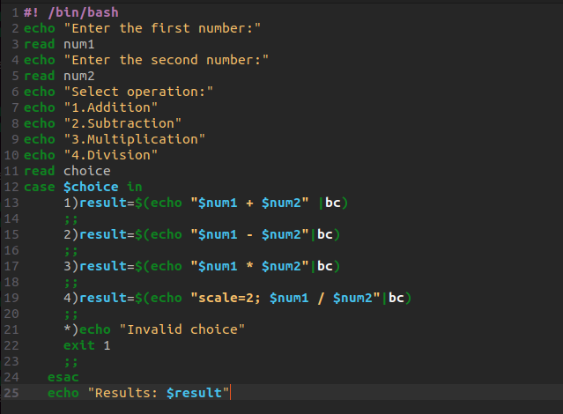 OUTPUT: 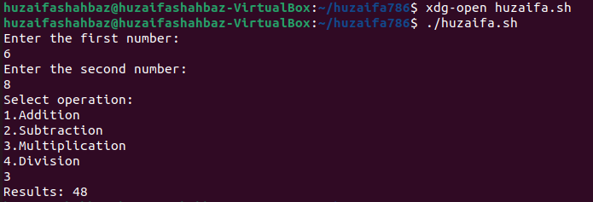
Task 8: Simulate command/commands in gedit that contains today’s date in script, execute the program and display its output. CODE: 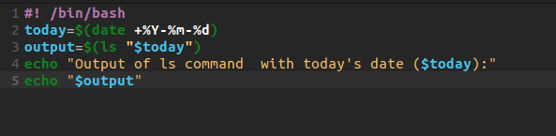 OUTPUT: 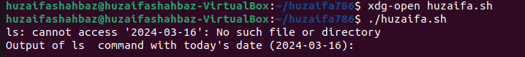
Task 9: Simulate command/commands in gedit that contains contents of your home directory in script, execute the program and display its output. CODE: 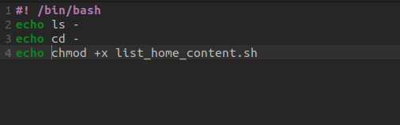 OUTPUT: 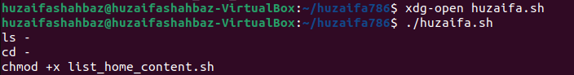
Task 10: Simulate command/commands in gedit that contains your present work directory in script, execute the program and display its output. CODE: 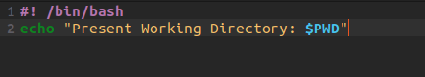 OUTPUT:
Task 11: Simulate the following commands in Linux and state which of the command is correct and why for printing your home directory location, a)$ echo $HOME OR (b)$ echo HOME CODE: A: 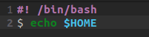 OUTPUT: B: 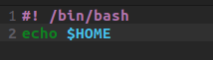 OUTPUT: Result: So,the part b $ echo HOME is the correct command for the Linux.
Conclusion: In conclusion,we had learn the how the commands of linux perform in textfile Basic Shell scripting using gedit/vi. Also we make the calculator by performing basic operation by Linux commands.

